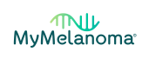

Dear Colleague,

A new British endeavour is about to start, and we need your help to publicise the opportunity for patients to take part!

The plan is to recruit at least 20,000 people treated for melanoma in the NHS, to the world’s biggest cohort. The participants will be asked to provide information about their lifestyle, treatment, quality of life and their personal and family medical history, which will enable us to build a unique data base of data required to address the key questions of importance for melanoma patients in the future. The participant entered data will be linked securely to stored NHS data and we hope to collect blood, stool and tumour samples over time. Notably this will be an accessible resource: bona fide researchers worldwide will be able to apply for access to anonymised data, in order to speed up progress in research,

The full details of the study are available on the website www.mymelanomastudy.org via which potential participants can access the Participant Information and via which they can proceed to consent and participation. This image shows the landing page for potential participants.

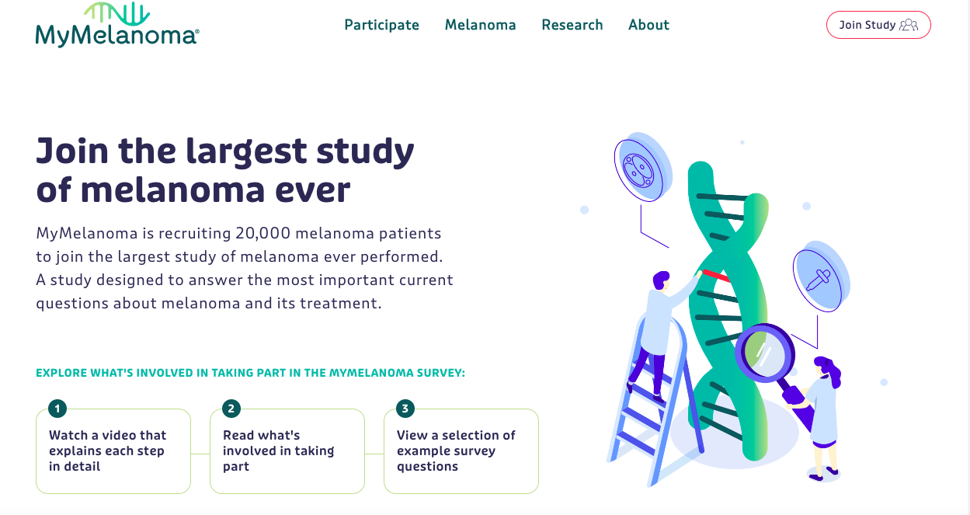

We are going to start recruiting a subgroup of participants from October 17th: those with a personal or family history which is suggestive of inherited predisposition to melanoma, OR who have been tested and are known to carry a high penetrance susceptibility gene, such as CDKN2A, CDK4, POT1 or TERT. We anticipate broadening recruitment to any person who has had a melanoma treated by the NHS in England or the devolved nations in the new year.

We attach the ethically approved flyers which can be given to potential potential participants. We would be grateful if patients with the following histories could be alerted to the possibility of participating in MyMelanoma.

- A person (irrespective of their melanoma status) who has already had a positive germline test for high-risk cancer susceptibility gene and knows their result (excluding the lower risk gene called MC1R). Any gene for which there is good evidence that it is a high penetrance cancer susceptibility gene will be included. Those genes would include CDKN2A, CDK4, BRCA2, POT1, TERT, BAP1, ACD, TERF2IP, MITF or a gene discovered in the follow-up period as associated with high melanoma risk. Genes primarily associated with risk of cancer other than melanoma will also be an inclusion criterion such as a mutation in any of the genes above or in TP53, RB1, CHEK2, PTEN or NF1.
- A melanoma patient who reports that two or more first-degree relatives have had treatment for, or have died of any of the listed cancer types: A brain tumour, breast cancer (under 45 years, in a man or bilateral), colon cancer under the age of 50, ovarian cancer, pancreatic cancer, kidney cancer, lung cancer, mesothelioma, melanoma of the skin, melanoma of the eye, bone cancer, laryngeal cancer, sarcoma, prostate cancer (if treated), blood cancer (leukaemia, lymphoma etc) or cholangiocarcinoma.
- A melanoma patient who has already had treatment for two other types of cancer included in the list above.

Professor Julia Newton-Bishop. University of Leeds j.a.newton-bishop@leeds.ac.uk
Professor Mark Middleton University of Oxford mark.middleton@oncology.oxon.ac.uk
Dr Antonia Pritchard University of the Highlands and Islands,
antonia.pritchard@uhi.ac.uk

