

**Harbourside Health Centre**

**Guide to register for My Health Online**

If you would like to order your repeat prescriptions online, you need to sign up for My Health Online. To do this please email the practice at [Harbourside.Healthcentre@wales.nhs.uk](mailto:Harbourside.Healthcentre@wales.nhs.uk)

Once we have received your email we will send you a form to complete and return to us (click on the word document below to view a copy of the form).



After processing your form, you will receive your login details by e-mail. We ask that you login within 48 hours of receiving this email to activate your account. Follow the link below, which will take you to the correct My Health Online page for our practice.

<https://www.myhealthonline-emisweb.wales.nhs.uk/account/login?ReturnUrl=%2F>

Select your language choice

You will see the following page

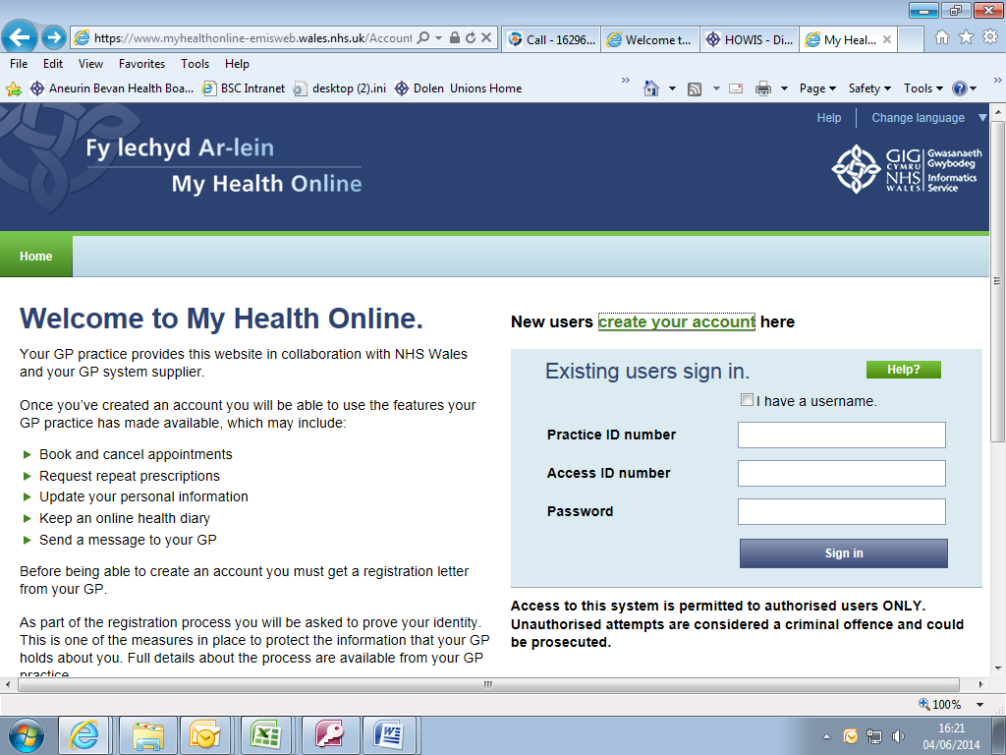

Click here to activate your account

Using the information on your registration letter complete the required fields.

**Screen 1**

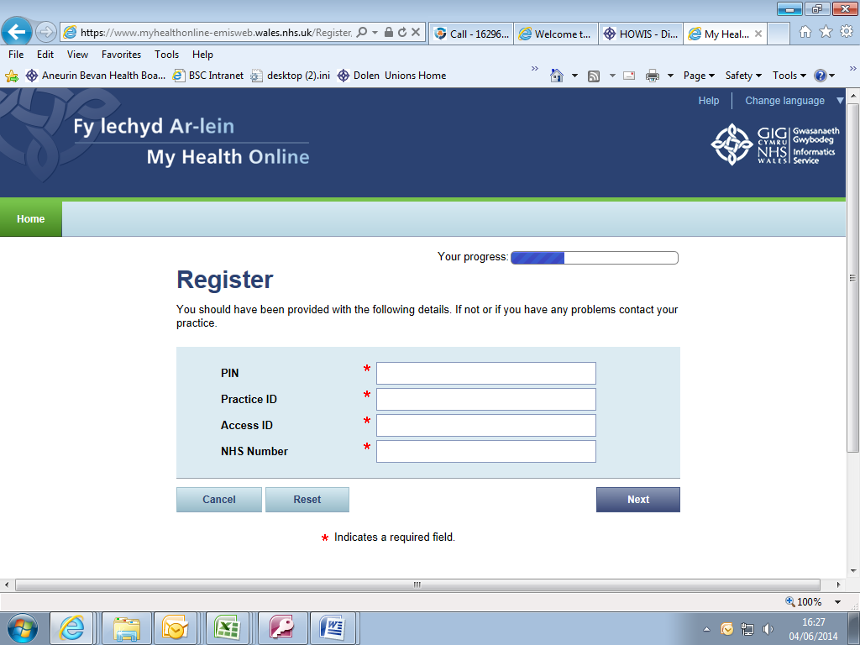

**Screen 2**

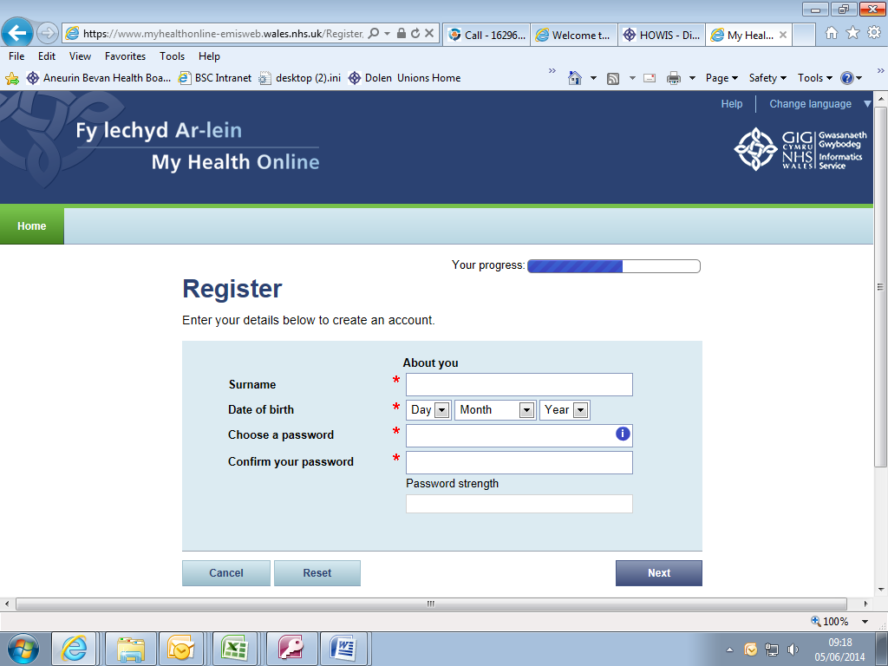

**Screen 3**

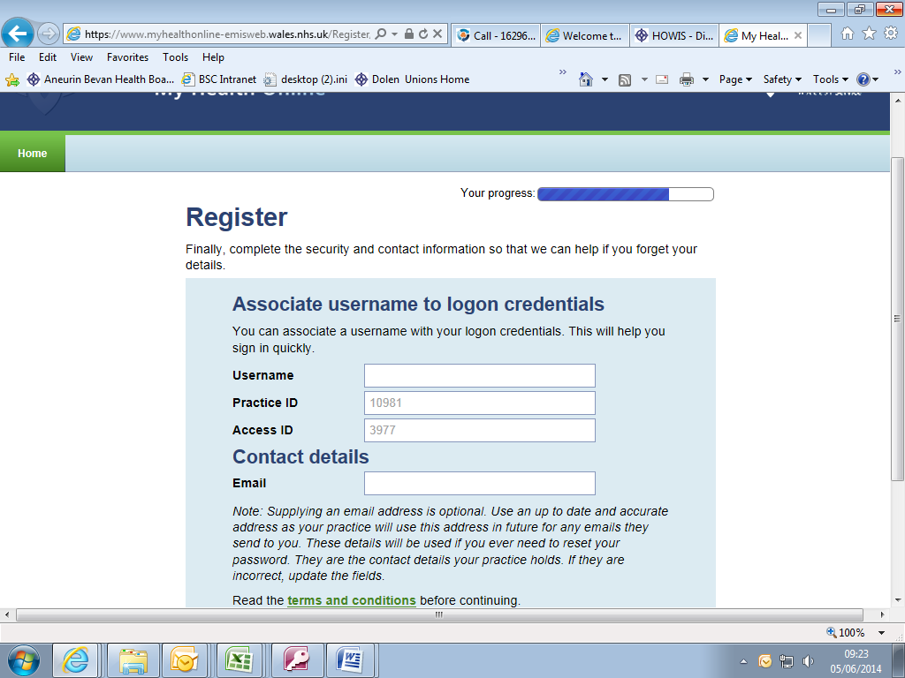

Your My Health Online account is now active. You can now sign in and proceed to: Order repeat prescriptions.

**Signing in & Using My Health Online from now on**

1. In your internet browser, type or copy and paste, the following web address: <https://www.myhealthonline-emisweb.wales.nhs.uk/account/login?ReturnUrl=%2F>

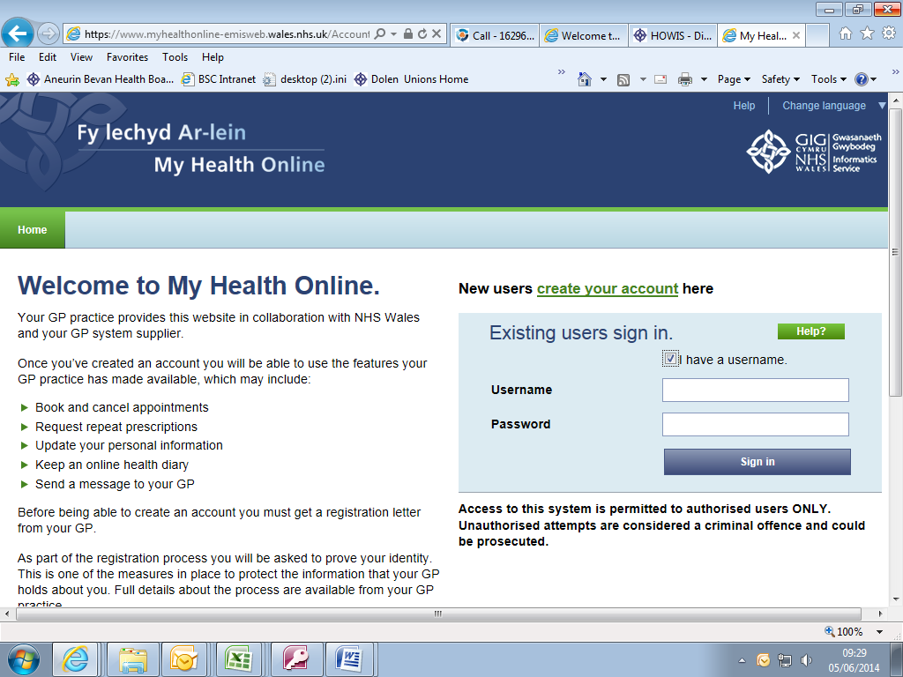

Put a tick in this box. Then complete 2 login boxes. Finally press sign in button

The home page appears

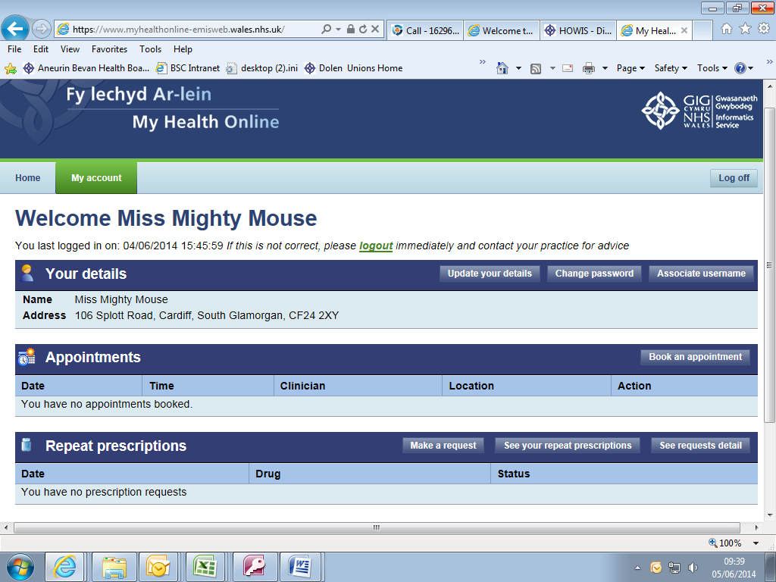

To order repeat medication click on the ‘Make a Request’ button

If ever you need to update your details, change password etc click here

You will be taken to a screen with a list of all your available medication.

Put a tick in the box here of each item you require

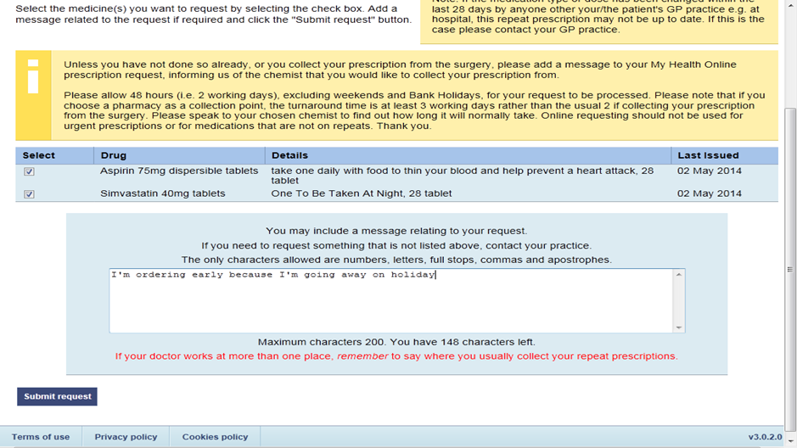

Finally click on the ‘Submit Request’ button you can send a brief message to the surgery by typing in this box

Once you have submitted your request you will be taken to the following screen that will confirm your request.

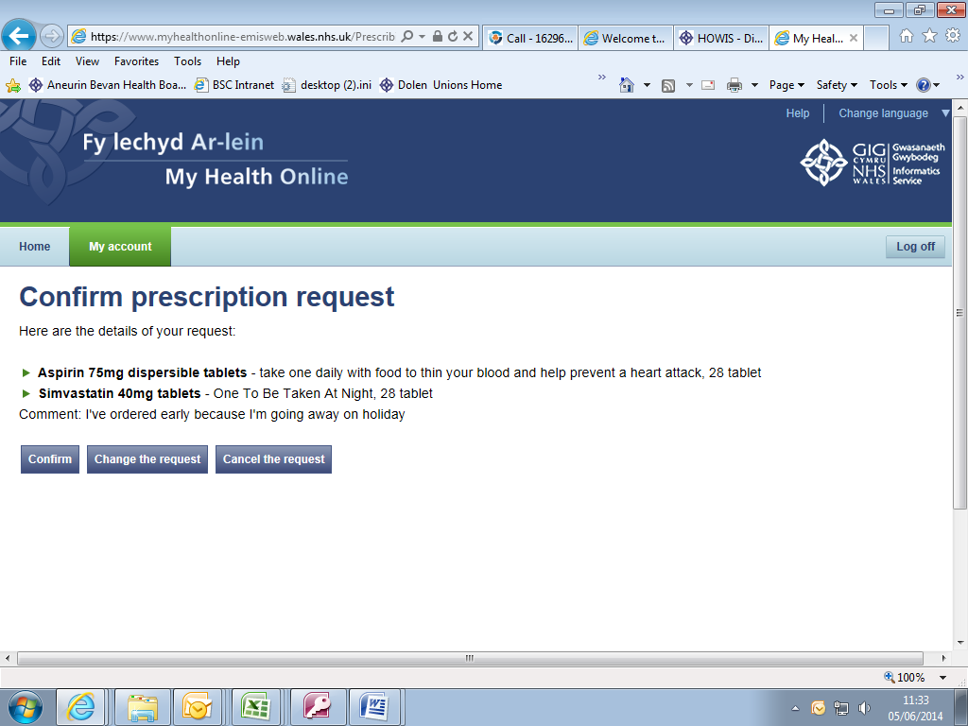

By clicking this button you are confirming your request and will go to the screen that states ‘Prescription Request Confirmed’.

The next button ‘change the request’ or third button ‘cancel the request’ allows you to edit your request.

By going back to the home page you will be able to see the status of your request.



Requested – waiting for processing.

Rejected/cancelled – contact the practice for the reason.

Issued – the request has been approved. Allow up to 2 working days before collection.

**Updating your Personal Details**

You can change your password and username from the home screen by clicking the relevant button.

You are also able to update your details from the home screen by clicking onto the ‘Update your Details’ button. This will then take you to a screen where you can update your address, phone numbers and email address.

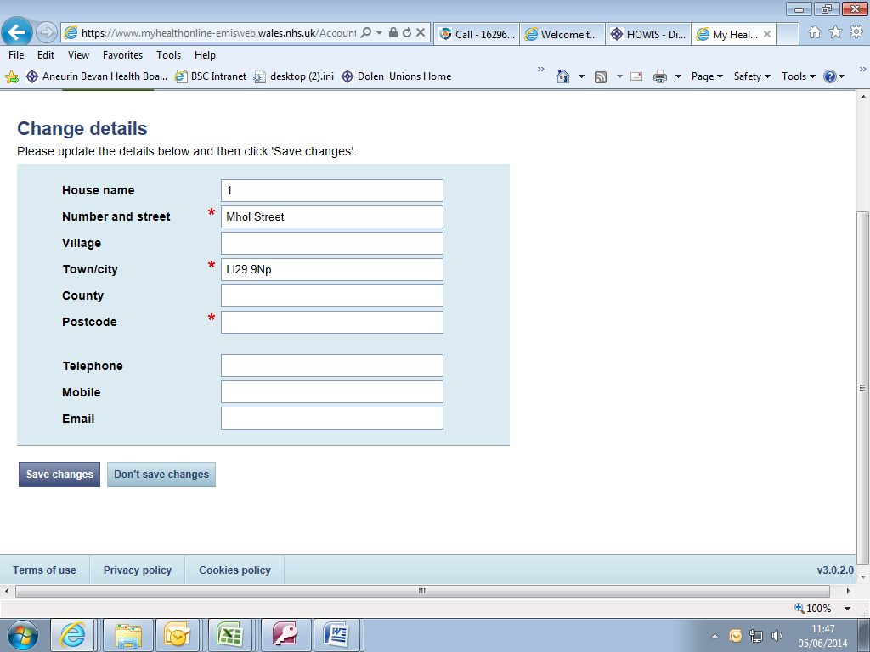

**Troubleshooting**

1. If when registering, the system states your details are incorrect, please try again and copy the details exactly as they are on the registration letter provided by your practice.

If you are still experiencing a problem please

e-mail [Amb_myhealthonline@wales.nhs.uk](mailto:Amb_myhealthonline@wales.nhs.uk)

providing your practice ID, your full name and the error message you are getting.

1. If you are trying to log in, but the system gives you an error message – please e-mail [Amb_myhealthonline@wales.nhs.uk](mailto:Amb_myhealthonline@wales.nhs.uk) providing your practice ID, your full name and the error message you are getting.